CK19 Mouse Monoclonal Antibody (11F5)

CATALOG NUMBER: C1352

QUANTITY: 50µL
DESCRIPTION: This protein is a member of the keratin family. The type I cytokeratins consist of acidic proteins which are arranged in pairs of heterotypic keratin chains. Unlike its related family members, this smallest known acidic cytokeratin is not paired with a basic cytokeratin in epithelial cells. It is specifically expressed in the periderm, the transiently superficial layer that envelopes the developing epidermis. Keratin 19 is not expressed in hepatocytes, therefore, antibody to keratin 19 is useful in the identification of liver metastasis. The degree of keratin 19 positivity in breast cancer distinguishes malignant from benign tumours. Keratin 19 is often co-expressed with keratin 7.
SPECIFICITY: Human, Mouse, Rabbit

ISOTYPE: IgG1

MOLECULAR WEIGHT: ~44KD

APPLICATIONS: IHC: 1:200

*NOTE: Optimal working dilutions must be determined by the end user
STORAGE/HANDING: PBS, pH 7.4, containing 0.02% sodium azide as Preservative and 50% Glycerol. Store at -20°C. Do not aliquot the antibody.

Immunochemistry
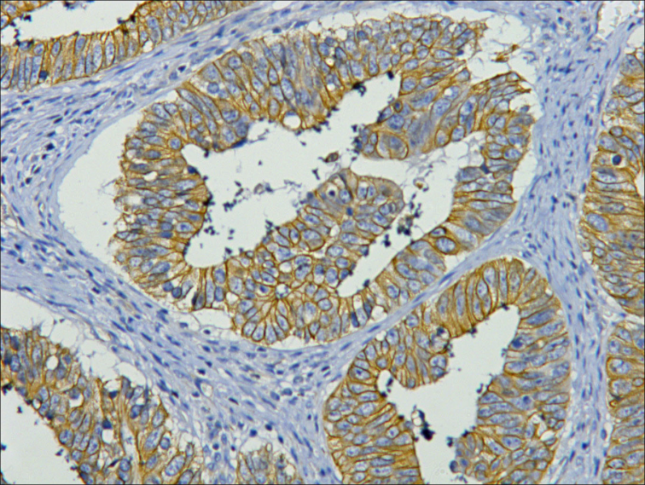
IHC staining of human colon cancer tissue with CK19 mouse mAb(11F5) diluted at 1:200.

For research use only; not for use as a diagnostic.
Important Note: During shipment, small volumes of product will occasionally become entrapped in the seal of the product vial. For products with volumes of 200 µL or less, we recommend gently dislodge any liquid in the container,‘s cap.

